Sample description: age and gender

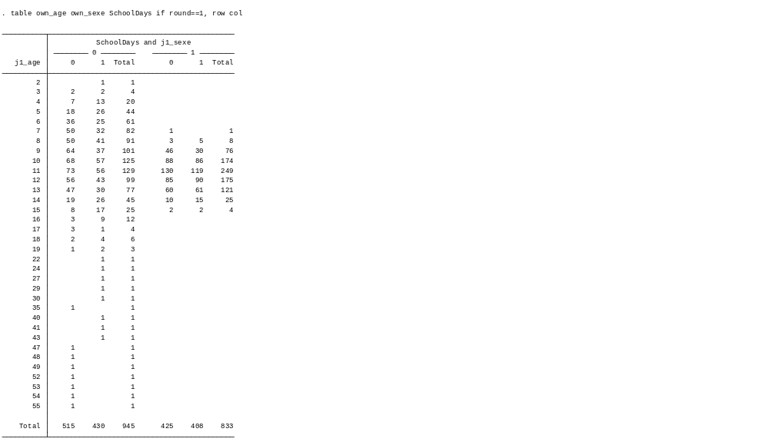
Interaction between communication and gender:

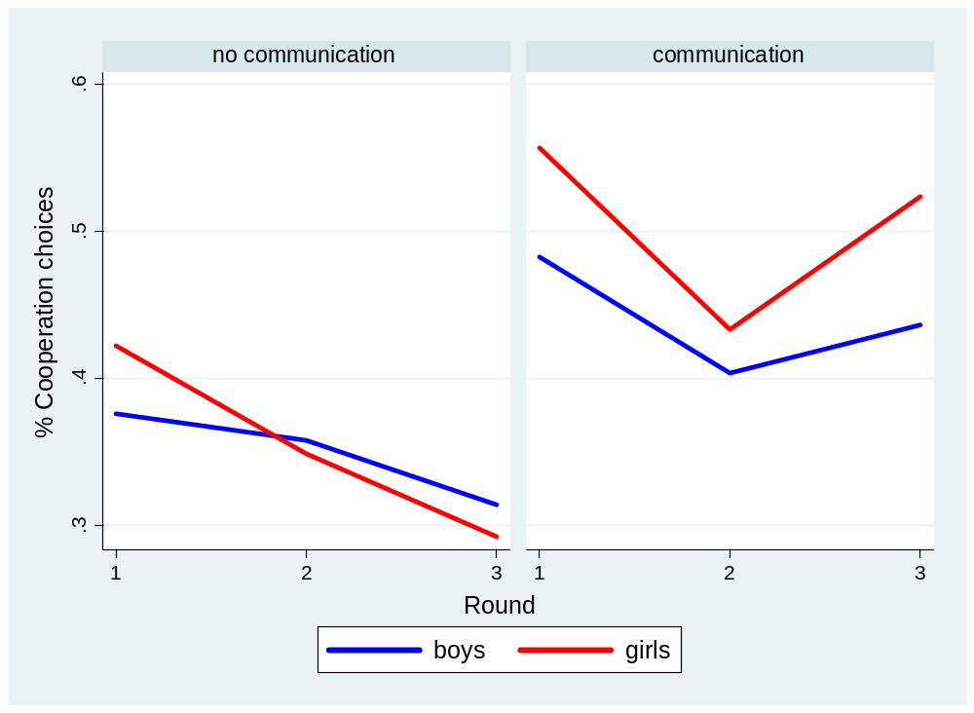

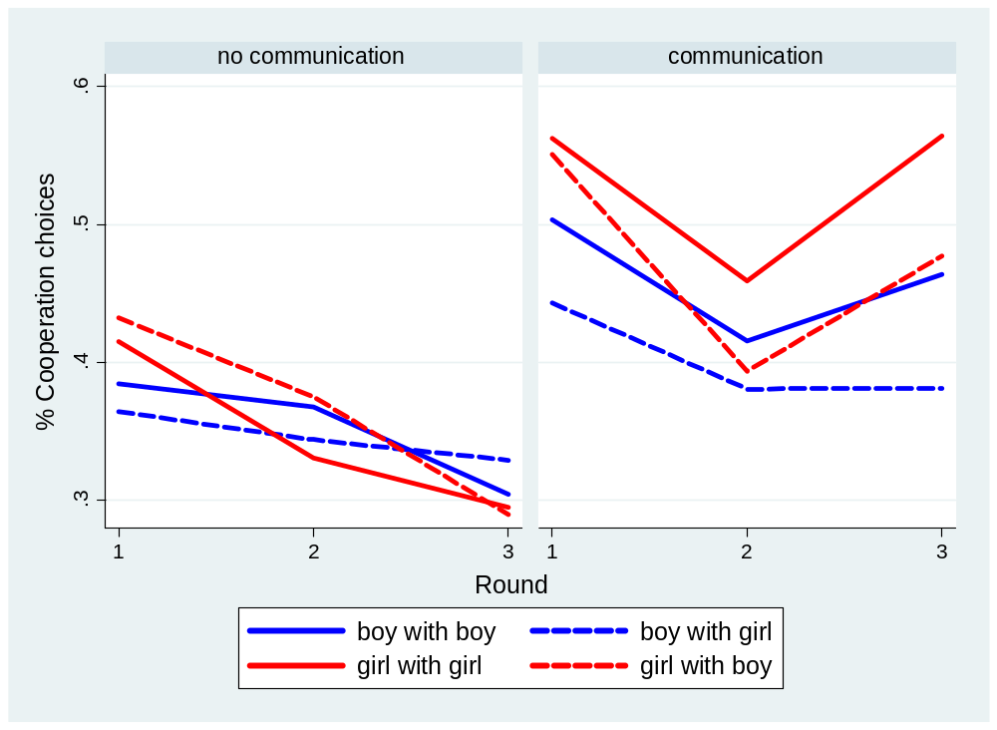

The graphs before are from the entire data, the interaction-effect commXgender, however, is only present in the data from the schools (Thursday Friday)…

Regression Results with only SchoolDays data:
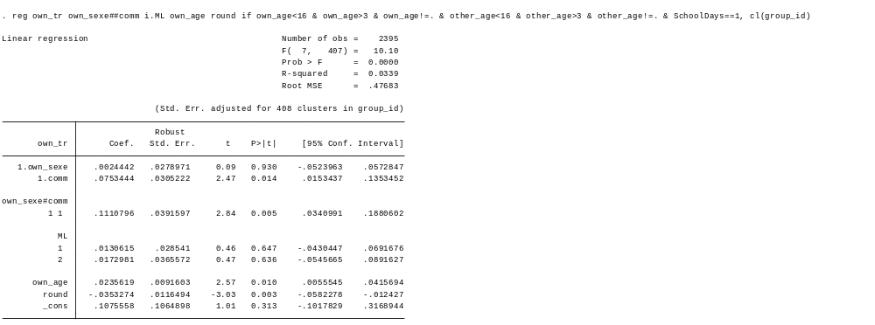

Regression results with only Saturday / Sunday data:
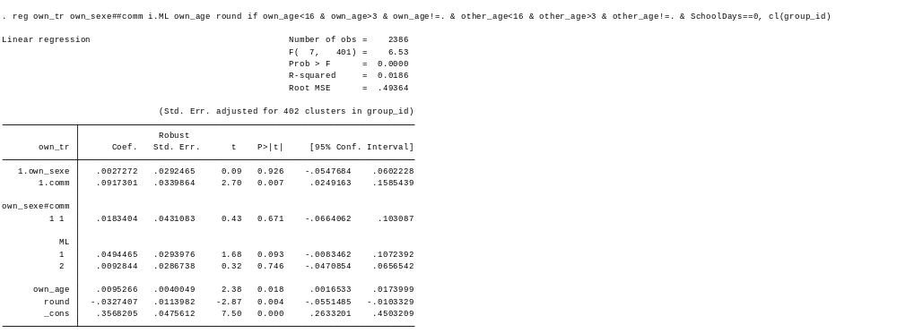
Graphs when looking only at the Schooldays subset (ClusterN=408):

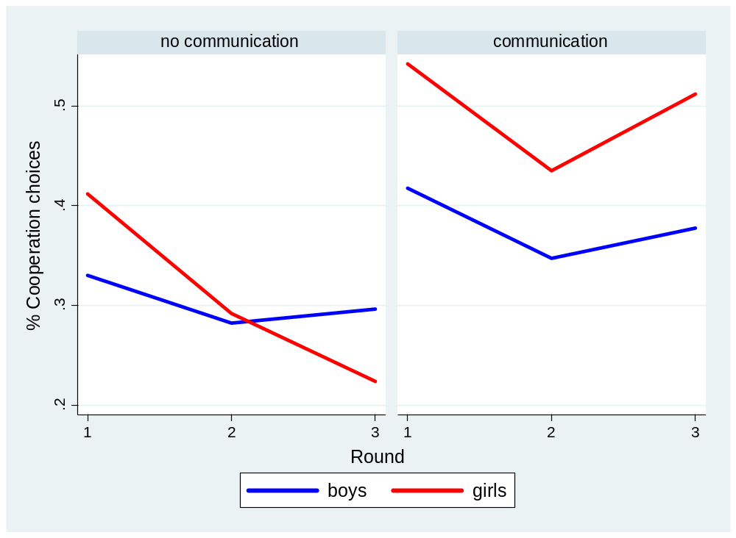

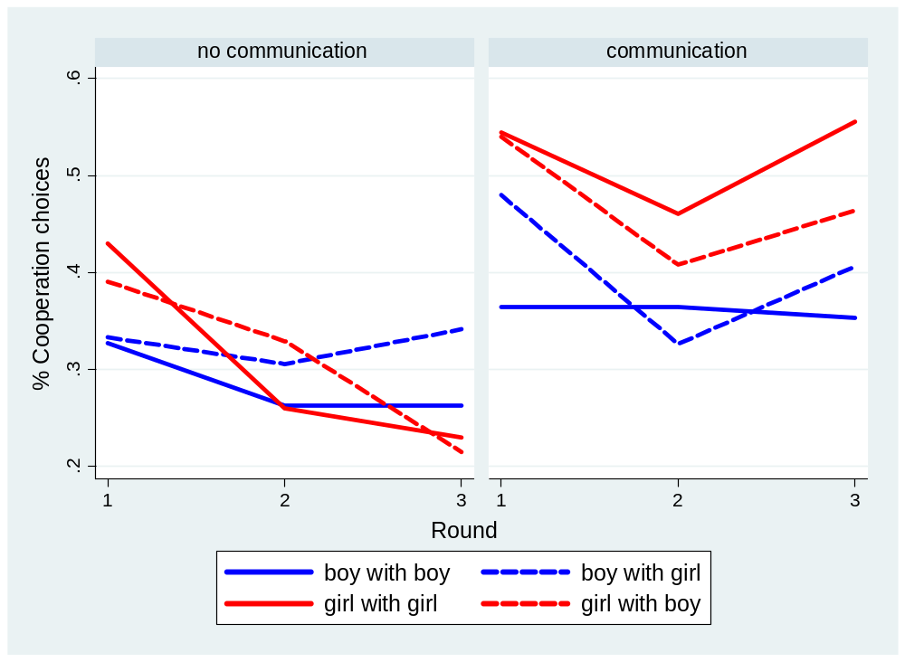
Age Gender Communication patterns in SchoolDays data overall:

